Working in the Cloud

with ClearMedia Academy

ClearMedia O365 ProPlus deployment

**Disclaimer**:

By using the ClearMedia vCloud Director templates, you can greatly reduce the amount of time needed to deploy new VMs. These templates have been configured with the best practices in mind, to assure optimal stability and performance. Although use of the template is not compulsory, it is recommended!

This guide assumes you are building a new vApp based on Template version 1.5 and deploying the template from the “Catalog” tab with a single server setup or “All-In-One” (AIO) server.

In-Depth explanation and step-by-step procedures

**Office 365 Pro Plus Activation**

* Before you activate the O365 contract in the ClearMedia portal you should check a few items first. It is not needed for the “install” of the O365 Pro Plus software, but you do need it for the activation step. It will also help make things go smoother.
* Check the document Office 365 CSP Migration.xps. You can find it in the repository or on the template server (folder “C:\iNSTALL\O365\Office 365 CSP Migration.xps”).
* If you do not know the tenant ID (MS ID), you can use the “Get_O365_TenantID.ps1” script, located on the cloud server, which will retrieve this, based on the customer Domain Name.
* For example, your customers domain name is “customer.be” then just type in the same in the script.

**Office 365 Pro Plus Installation**

* We assume that you have started from the VMware Template 1.4 Document.
* Open the server where you would like to install the O365 suite.
* Open folder C:\iNSTALL\O365\ .
* Run the InstallO365ProPlus.cmd script.
* Choose either 32 or 64 bit installation type.

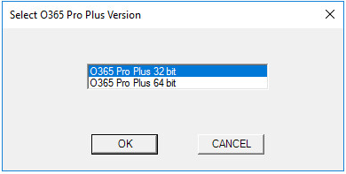

* Wait for the script to download the setup files, which can take a while.



* After the download has completed, the installation setup of Microsoft Office 365 suite will start.

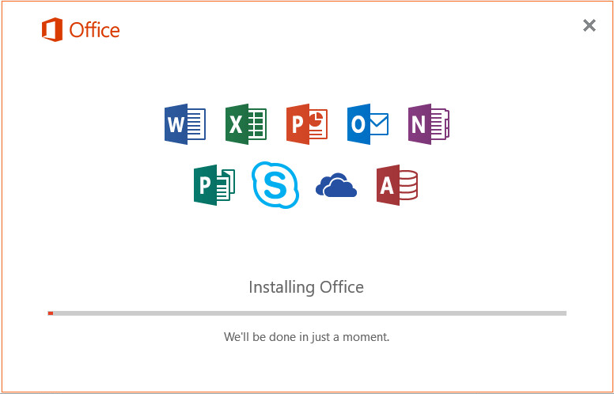

If you have not activated the 0365 contract/quote in the ClearMedia portal yet, just must do so now, in order to get the necessary 0365 user credentials. Without 0365 user credentials you cannot activate/use the software. See “**Office 365 Activation**” for the necessary steps.

* To activate O365, just open one of the products (Word, Excel, PowerPoint, Outlook) choose “Sign In” and enter your customers 0365 user credentials.
* **Finished!**